THE BOURNE: TRACING THE DEVELOPMENT OF A SMALL COMMUNITY
By Richard Sandars

Set up in 2002 as a volunteer organisation with the aim of helping to maintain and improve public open areas and rights-of-way in The Bourne, the Bourne Conservation Group (BCG)has since widened its activities to include both enhancing biodiversity and researching the history and development of the area, both of which have underpinned the project undertaken by the group since the Autumn of 2008 to restore and maintain the community’s now unused Old Churchyard as a wildlife site and historic asset.
Finding a starting point
As a small semi rural, residential area, the Bourne has a rich and quite compact history of its own.
Few small communities have had the good fortune to have had such an observant and meticulous chronicler as George Sturt. His long standing friend, Arnold Bennett, described him as “a dark man with regular features, fine benevolent eyes, and an old-fashioned dark beard” who had a “steely and everlasting hatred of all sentimentality. He said what he thought, or he said nothing. To his friends he said everything”. For anyone expecting to be ‘entertained’ by anecdotes of the “quaint old fellows in the village” he had no time.
Having passed the management of the family wheelwright’s shop in Farnham, which he and his brother Frank had inherited from their father, to a foreman manager, William Goatcher, in 1891, Sturt moved from the town to the Bourne to live with his two unmarried sisters, Mary and Susan, at Vine Cottage. The cottage, about half way down what is now Old Church Lane, was built in 1805 as one of a row of three that had been run together as a single residence soon afterwards. Sturt remained at Vine Cottage until his death in 1927. During this time, and encouraged by Arnold Bennett, he maintained a Journal and wrote a number of books, including two long standing favourites –‘A small boy in the sixties’ recalling his childhood in Farnham and written in 1927 shortly before he died, and ‘The Wheelwright’s Shop’ (1923) describing the working lives of highly skilled craftsmen, the tools and materials they used while wryly bemoaning the “the misery of being a socialist employer of labour”. The New Statesman rightly predicted that ‘The Wheelwright’s Shop’ could well become a classic, while the Times Literary Supplement remarked that it “shows the author’s combination of the gifts of the handicraftsman with the powers of a writer in a way not common in English Literature.”
In ‘Literary Englands’, (1993) David Gervais suggests two ways of reading Sturt “one which dwells on his mastery of fact and one which finds in him a prophet who goes beyond simple observation to challenge our received view of ourselves”.In concluding his essay on Sturt and the influence he had on the influential literary critic F.R.Leavis, David Gervais puts the question “Has any English writer known his own particular England as closely as Sturt knew his”.

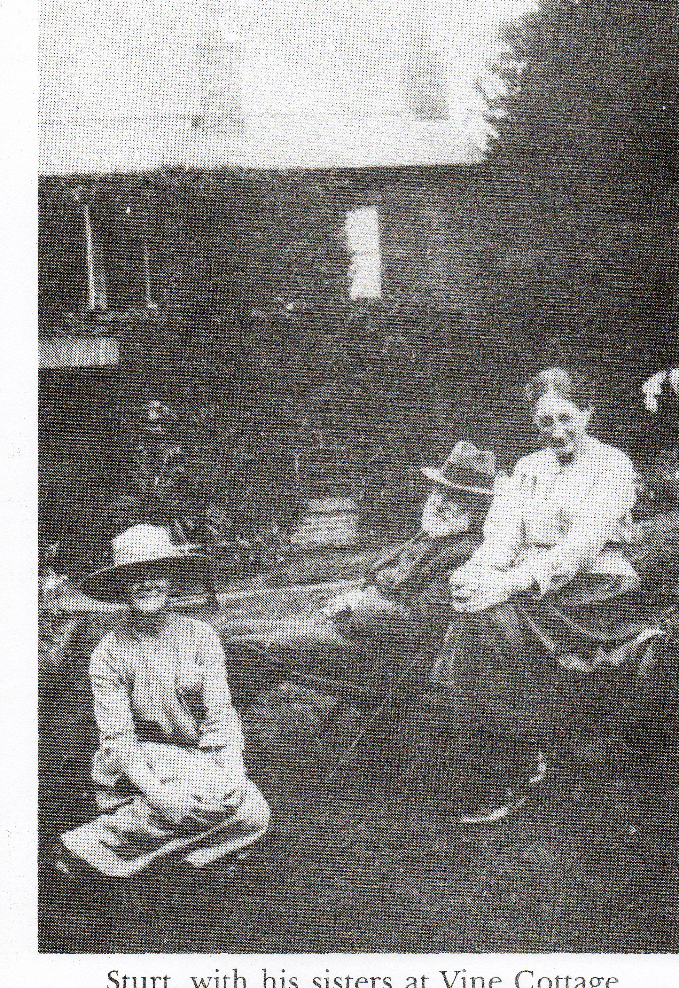In “Change in the Village” (1912) Sturt supposed that it would be wrong to define the scattering of cottages dotted about the steep slopes of the Bourne valley and beside the road to Hindhead as a village in the traditional sense, although the emergence of these homes was part of the series of changes by which the valley turned “from a desolate wrinkle in the heaths into the anomalous suburb it has become today” The poor level of fertility in the area generally and the consequent absence of an established community is largely down to the geology of the area, located as it is on the Folkestone Beds of the Lower Greensand deposited some 130 million years ago. In was Sturt’s view that the heathland had remained largely uninhabited until the middle of the eighteen century, perhaps, when ‘squatters’ from neighbouring parishes had settled around the more fertile stream bed area , grazing their animals on the open heathland and cutting timber and turf on the common to meet their every day needs. While enclosures of the common land had taken place since the Middle ages, those of the early nineteenth century had come to the Bourne in the early 1860s - much later than to other parts of the country. The effects of enclosures across the country are described also in J.L and Barbara Hammond’s ‘The Village Labourer’ (1911).
Commercial farming methods, the growth of an alternative money economy and widespread poverty was already overturning the traditional ways of rural life with its emphasis on self sufficiency and co-operation arising from shared communal rights. Sturt saw that the progressive loss of heathland grazing as having the effect of hastening changes that were already under way. Instead of being one of a group of villagers, “tolerably of the rest of the world”, the men and women of the valley were becoming increasingly dependent on competing for, and acquiring stable employment, much of it provided (with some ill grace) by the new leisured middle class. It was the ‘resident trippers’ lack of understanding or empathy for the social environment into which they were moving and the desire to impose their standards of life and culture that so appalled Sturt .
“The enclosure was effected in the usual fashion: a few adjacent landowners obtained the lion’s share, while the cottagers came in for small allotments. These allotments, of little use to their owners and in many cases soon sold for a few pounds apiece, became the sites of the first few cottages for a new population, who slowly drifted in and settled down, as far as might be to the habits and outlook of their predecessors. This second period continued until about 1900. And now, during the last ten years, a yet greater change has been going on. The valley has been ‘discovered’ as a ‘residential centre’ “
The ‘predecessors’ to whom Sturt refers were those settlers or squatters who had previously had customary rights to the common land, who had used the materials that were to hand , mainly turf and timber to build and then heat their rudimentary homes.
Whatever the particular combination of underlying catalysts, deep changes in social structures and styles of living were clearly a feature of the period, even if there was little, if any, improvement in the meagre conditions and wages of labourers. For Sturt there appeared to be a diminished requirement for the new labourer to exercise his initiative, or to be able achieve pride in his work. While there was more time for leisure, the labourer was ill equipped to benefit from this. The elementary education received by the majority of children at the time did little to enrich their minds, he believed.
In the main, this ‘discovery’ of the valley can be put down to three particular events – the extension of the railway into the town in 1849 the establishment of the Aldershot Garrison in 1855, and access to a mains water supply
A new focus for a developing community
To cater for this increasing population, and to ease pressure on St Andrew’s Church in Farnham, work started in 1861 on building a small chapel of ease on land given by the Revd. John Martyr Ward, owner of the Firgrove Estate. The available site was on the ridge between the town and the Bourne Stream. The completed Nave, costing £344, was dedicated the following year by the Bishop of Winchester, Charles Sumner.

In 1863 the avenue of lime trees and the two yew trees, at the northeast and northwest corners of the Churchyard, were planted by James Knight of Vernon House in Farnham to commemorate the wedding of the Prince and Princess of Wales. Construction of a Chancel and Vestry followed in 1869. In the same year the new church, able to cater for the then population of about 600 or so, was consecrated as St. Thomas-on-The-Bourne by Charles Sumner’s successor as Bishop of Winchester, Samuel Wilberforce -‘Soapy Sam’, recorded for posterity for his part in the acrimonious debates over Darwin’s ‘Origin of Species’. By the time of the first vicar, Thomas Sidebotham’s death in 1907 the population of the Bourne had reached some 2,000 and the church was no longer able to cope with the increased congregation. Construction on the present St Thomas- on –The-Bourne Church started in 1910 under the direction of Thomas Sidebotham’s son, Henry, the appointed architect. The last service in the original church was on September 30th.1911, after which the Altar was carried to its position in the side chapel of the new church

Researching the story of the Old Churchyard, alongside what we know of those who are buried there provides a unique and fascinating glimpse into a society that was evolving over the course of the 100 or so years between the building of the little church to serve the new parish (which was formally established in 1875), and the last burials which took place in the 1960s. Throughout this period the Church occupied a position of status and influence within the social structure of every community.
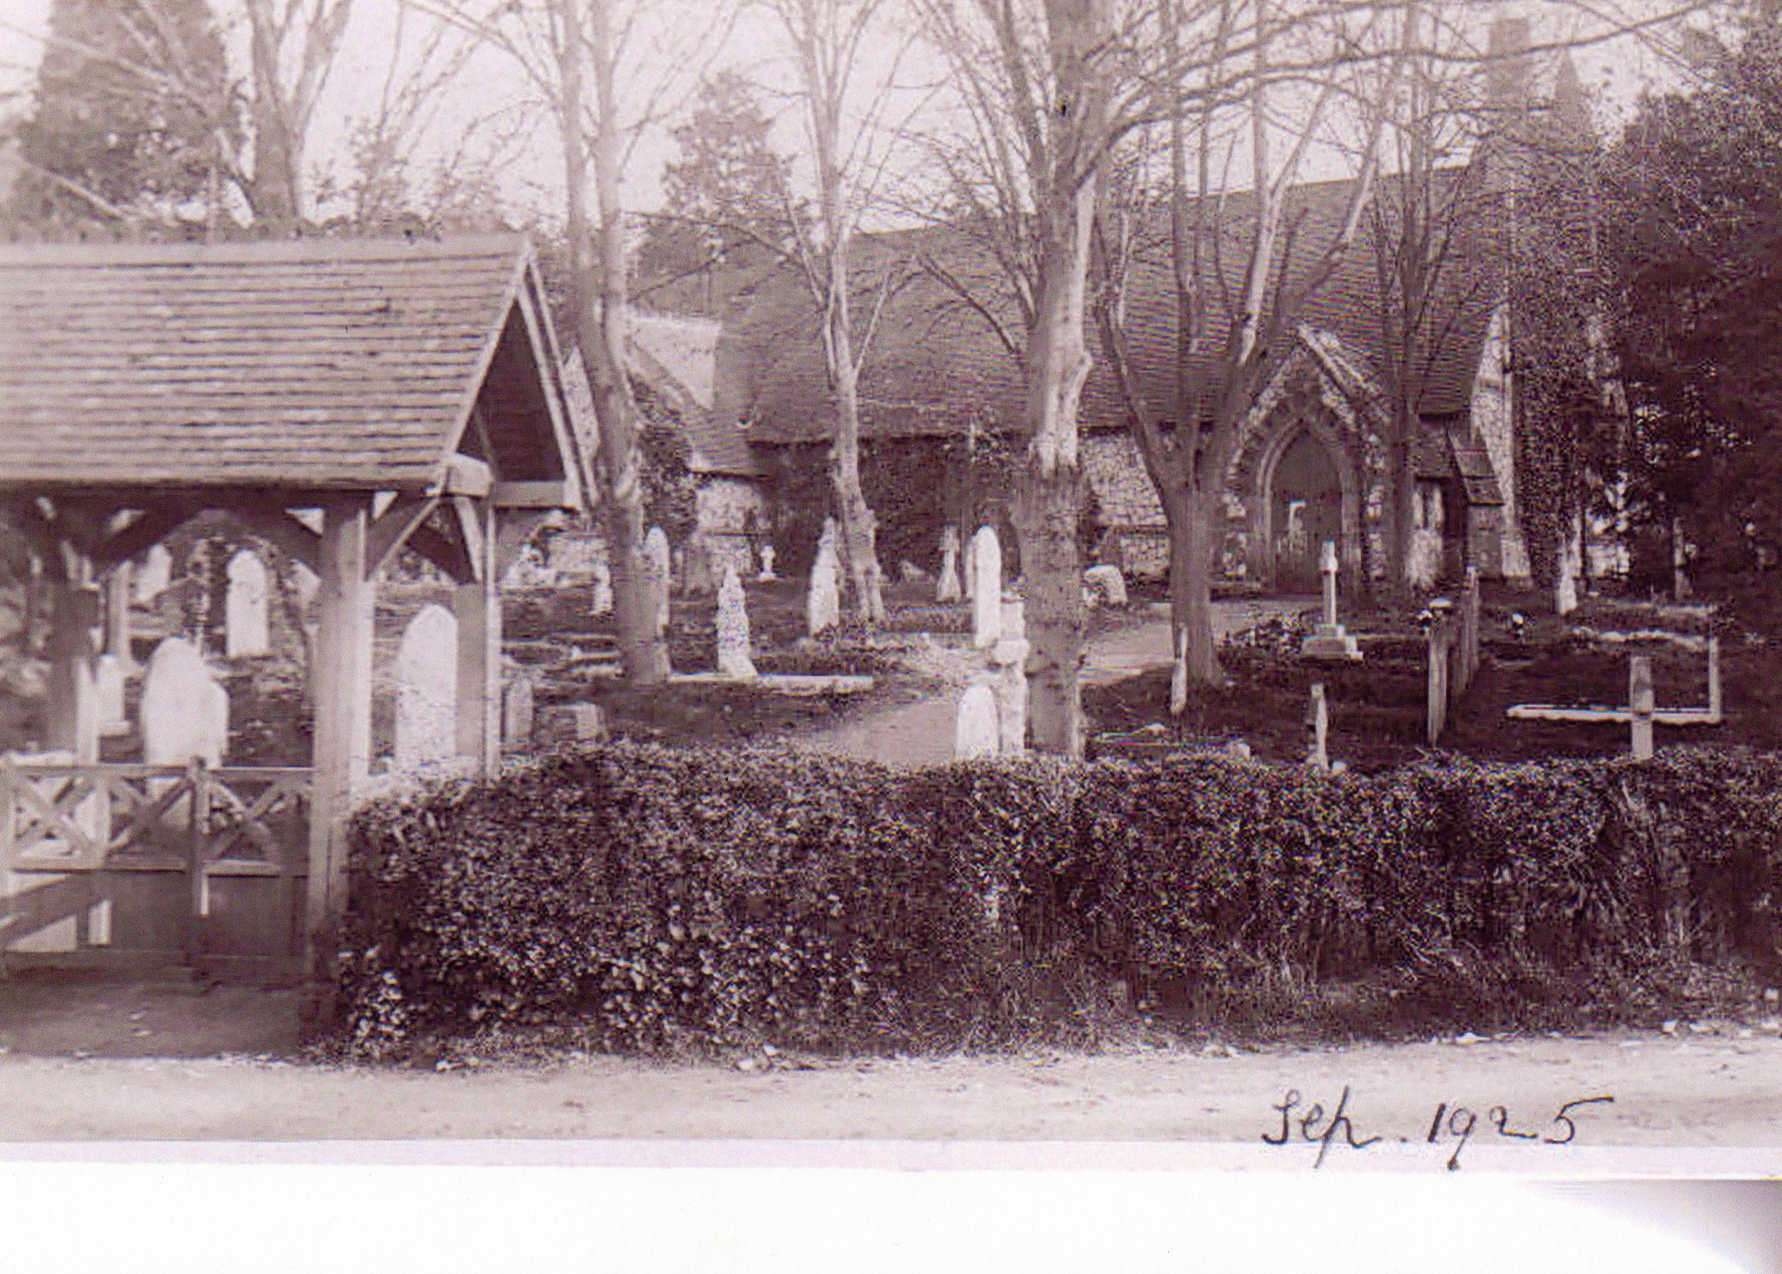
In 1874 Thomas Sidebotham, who had spent some time in Guernsey on the advice of his doctor, returned to England to take up an appointment, first as Curate in Charge and subsequently, in 1875, as Vicar to the newly created parish of St. Thomas-on-The Bourne. Building of the church was finally completed in May 1881, with the addition of a South Aisle and organ chamber and the layout of the churchyard being completed in 1888 when Thomas’ sister Ann, affectionately known in the Parish as ‘Miss Annie’ donated the necessary funds for the construction of the fine lychgate at the entrance to the churchyard. She was able to do this using the proceeds of the phenomenally successful Childrens’ Hymn Book which she co-edited with her friend Frances Brock, wife of the Dean of Guernsey. ‘Miss Annie’ was not only the Musical Editor but she also composed several of the hymn tunes, which she only permitted to be attributed under her initials MAS. Others who contributed included Sir Arthur Sullivan, Sir John Stainer and some family members.

The hymnbook was reflective of the considerable social change identified by Sturt, which included the setting up of children’s charities and the passing of legislation on education and child employment and welfare. By 1898 over one million copies had sold; the hymnbook remained in print until 1911.

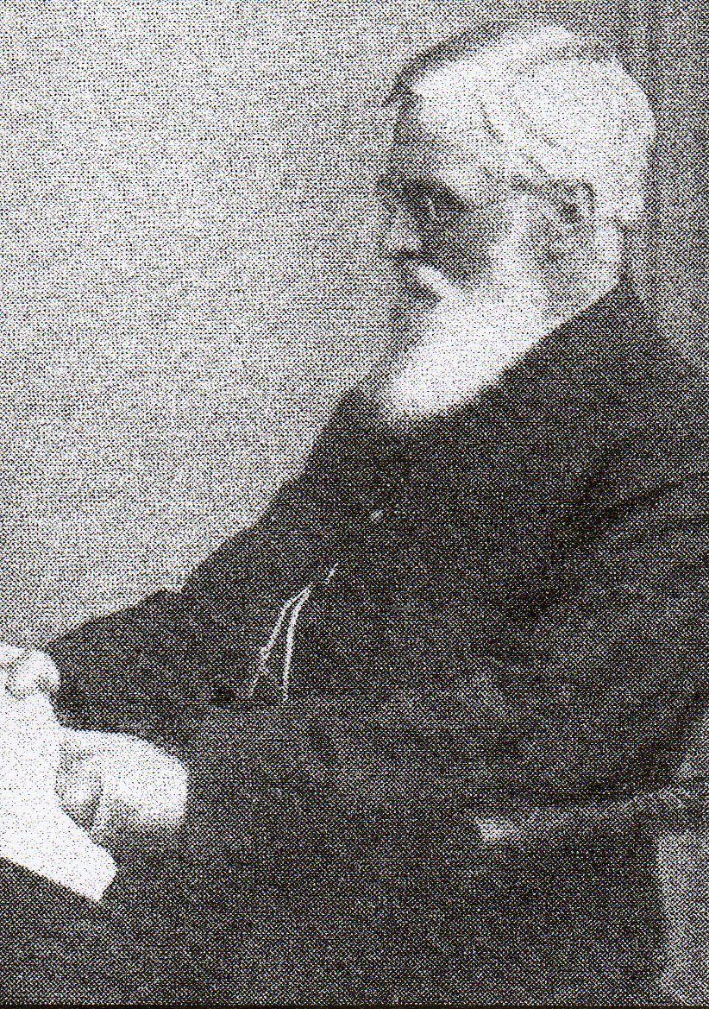
Thomas William Sidebotham | Mary Ann Sidebotham

Life at the vicarage was delightfully described by Thomas’ son Henry in “A short and Very Informal History of the Bourne” (1950 ) and by the second son of the second vicar, Edward Griffith, in “In and Around the Old Vicarage Fifty Years (and more) Years Ago”. Both were typed by their authors and are not now in circulation.

On a sombre note Henry, mentions that
“When the Vicarage was built in 1876 the well was sunk to a depth of 150 feet before water was reached. There came several years of bad drought, especially one year when the shallow wells of the cottages ran dry, and a bad epidemic of diptheria broke out. The villagers had to be supplied with water from either the deep well near Gravel Hill, or from the vicarage well, and the people came a long distance with two buckets and a hoop to fetch their water. The Gravel Hill well gave out, and had to be deepened some feet; this drained the vicarage well and that too had then to be deepened....water was at one time so scarce that personal washing of children was in some cases merely ‘a spit and a wipe’ and water used for boiling cabbages, etc., had to be used again”
In such conditions it is unsurprising that child mortality was high.
Referring to the same period, Edward Griffith speaks of a donkey and cable being used to turn the ‘huge wheel’ at the Vicarage which raised the water. As new and larger houses were beginning to be built mains water was brought into to the Bourne. Once this had happened, the speculative building boom that both Henry Sidebotham and George Sturt described got under way. However, as Henry pointed out, the costs involved meant that old cottages had to continue to rely on traditional sources for their water.

In Memoriam
About 200 of the 750 plots have recorded inscriptions and many have now been researched by BCG member Wendy Maddox. Some are clearly defined and identified with monuments or headstones , while others are little more than unmarked mounds. Among the first recorded burials were two young mothers in their twenties Charlotte Jeffrey (d.1866) and Julia Little (d.1871) and their two children, William Jeffrey aged 2 years and Ada Little aged 3 months - poignant evidence of the harsh social conditions experienced by many local families
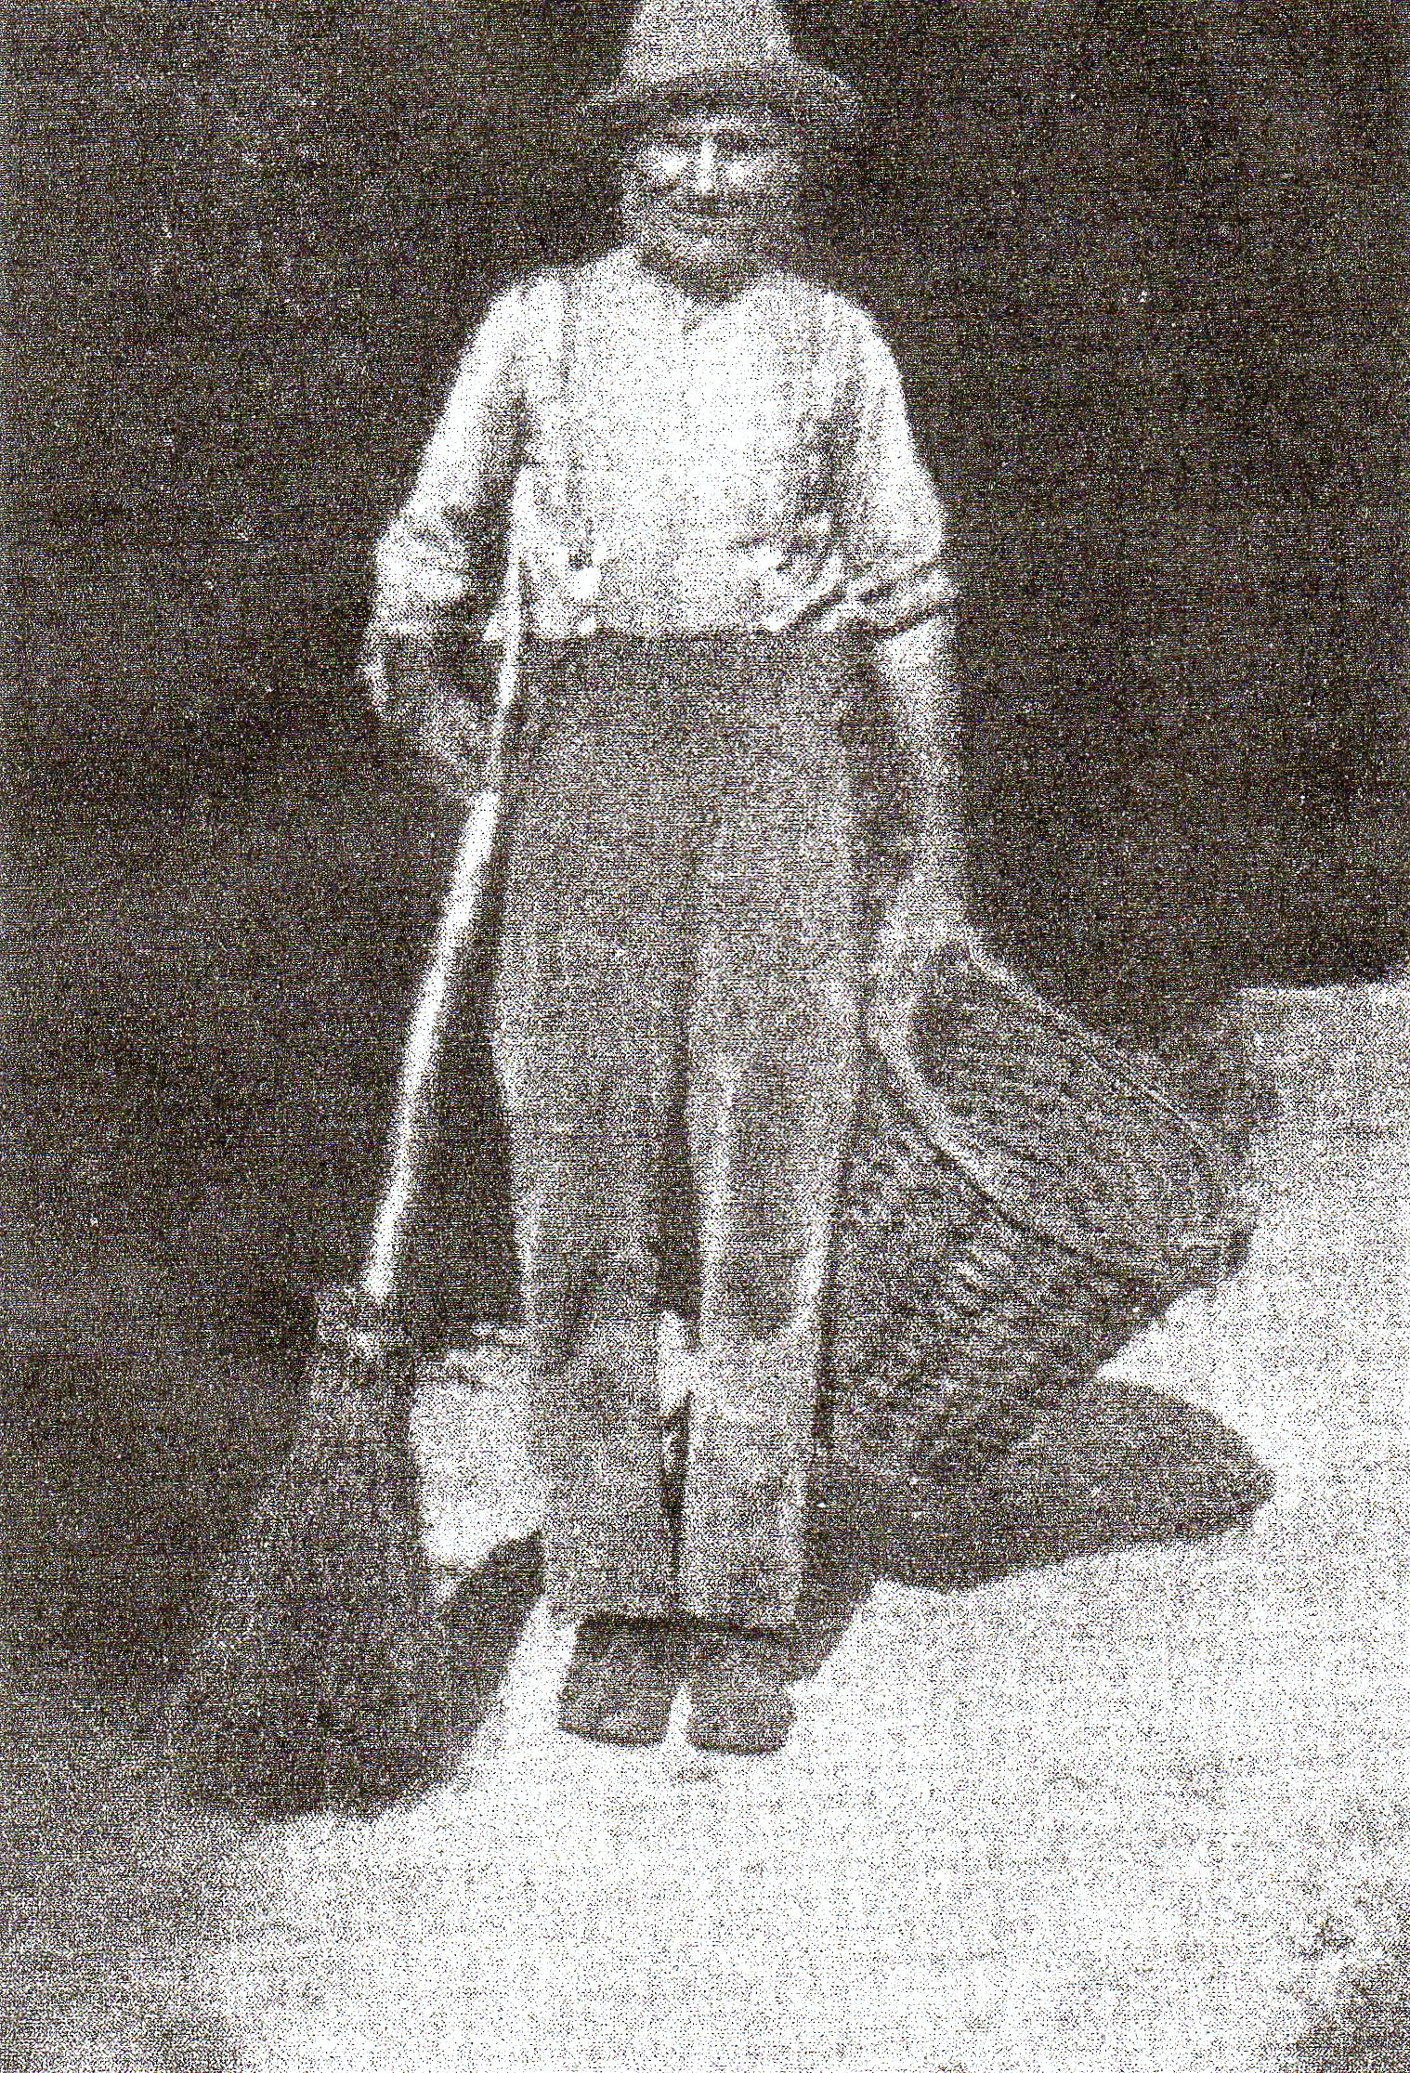Not far from where the north wall of the church would have been is an elaborate memorial to Thomas Sidebotham and his wife Bertha (recently restored), with his sister, Mary Anne’s grave beside it.
Near the commemorative yew tree at the northwest corner of the site are the unmarked graves of Fred Grover and his wife Lucy. Three of Sturt’s books revolve around the couple - “The Bettesworth Book” (1901), “Lucy Bettesworth” (1913),and best known, perhaps, “Memoirs of a Surrey Labourer “published in 1907. The “Memoirs” cover the period December 1892, until Fred’s death in 1905 during which he worked as Sturt’s gardener at Vine Cottage and entertained his employer with his “pleasant garrulity” and his “queer anecdotes and shrewd observations”. For a time, Fred and Lucy had rented ‘Little Willows’ on the path leading from Old Church Lane to Deepdene. What with Lucy’s history of epilepsy, having to cope with her violent, alcoholic and eventually suicidal father, his experiences of the workhouse and his brief experience of soldiering as a sixteen year old during the Crimean War, Fred’s life had been a hard one.
On the southern boundary of the churchyard is the tomb of Colonel Montague Wilbraham Taylor. On his return from India, the Colonel had come to live in Aveley Wood House on Gravel Hill (the A 287)and had, according to Henry Sidebotham, “set up a very smart Phaeton with a splendid pair of high stepping bays with a minute “Tiger” [a fierce, energetic or formidable person] in livery sitting behind with folded arms!” .He also set up a temperance hall (now the local scout hut – Taylor’s Hall) on the opposite side of the road to the Fox pub and alongside the now forgotten Happy Home pub.
Accepting that there could be problems on bank holidays, Sturt supported the traditional community’s need for beer and local pubs where families could gather and a labourer who had been working on the ballast trains all night, and whose wife might be out hop tying, could find relaxation and company.
“The institute does not lend itself to the easy intercourse which tired men enjoy at the public house, Its billiard table is not for their heavy hands, used to the pick axe and shovel; its card games interrupt their talk; its newspapers remind them they cannot read very well, and suggest a life they are unable to share”
With The Bourne providing an attractive residential area within easy reach of Aldershot, more than a dozen of the identified graves commemorate regular army officers and their relatives. These include Colonel George Chrystie and his son Major George Chrystie, both of whom served in the Indian Army; Major General Eric Paytherus Nares, CB, CBE, MC (and bar), a regular soldier, awarded the Legion of Merit by the U.S.A in 1946 for his support of American forces in Italy, who also served as Commandant British Troops in Berlin at the end of World War II; and Lieut.Colonel Simpson Powell RAMC, surgeon to the Grenadier Guards and Officer in Charge of Louise Margaret Hospital, Aldershot, who served also in India and China.
Other graves that may be of particular interest are those of Louisa Mary Mead who travelled from Guernsey with her mother and is recorded in the 1881 census as a 16 year old servant to Thomas and Bertha Sidebotham at the Vicarage; Patrick Lewis Paget, son of General Sir Edward Paget PC (Governor of Chelsea Hospital), who inherited Brightwell House from his father-in-law and whose daughter’s godmother was Florence Nightingale; and John Onion Slaught, a young Canadian who met and married Ella, daughter of the Farnham Superintendant of Police, Arthur Simmonds, while billeted in Farnham, en route for France. Awarded the MC, he was killed on 10 November 1918, the day before the war ended. John and Ella’s son, Arthur, was thereafter ’adopted’ by the policemen of Farnham. (Farnham Diary article September 2010).
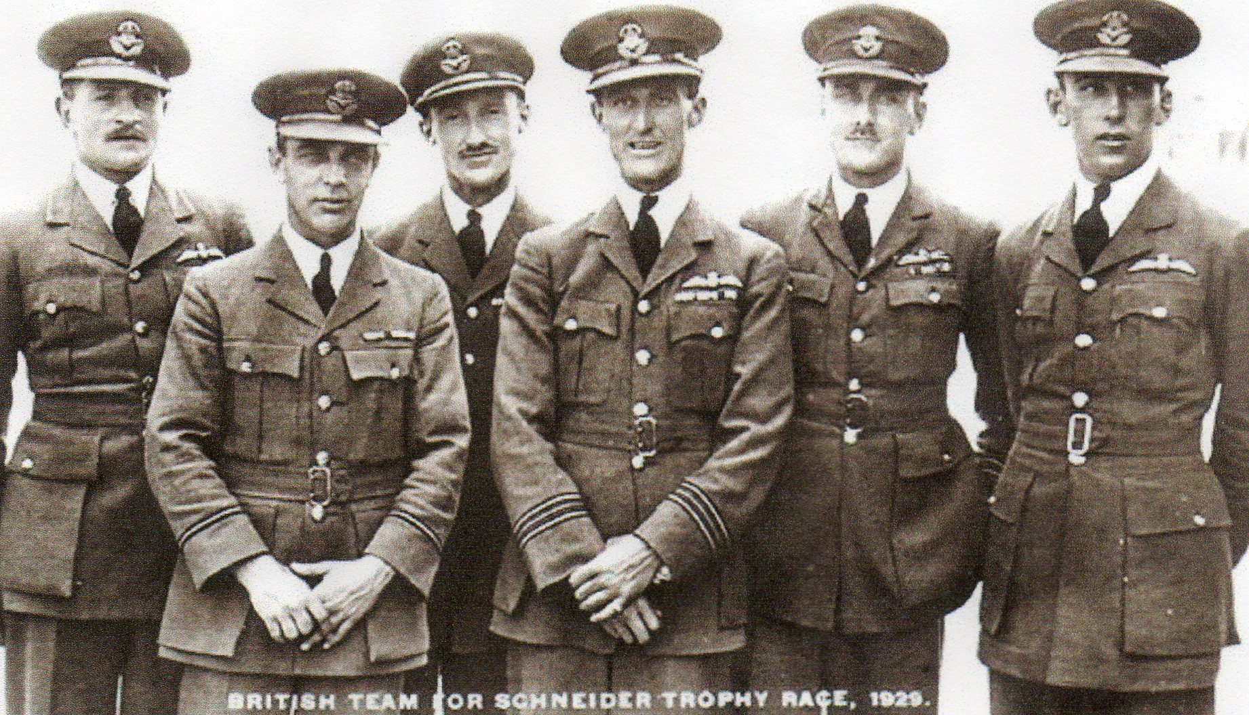Perhaps most well known is the grave of Flight Lt. Henry Richard Danvers Waghorn AFC. Educated at Wellington College and RAF Officer Cadet College, Cranwell, where he achieved the Sword of Honour as best ‘all round’ cadet, he was selected as one of the British Team to participate in the 1929 Schneider Trophy air race on the Solent, which he won, despite a forced landing through engine failure. Henry died of injuries sustained as a result of parachute failure when the Horsley bomber he was test flying from Farnborough went out of control. His burial in the Old Bourne Churchyard was attended by two Air Vice Marshals (Dowding & Lambe) and 1,000 other mourners. The RAF Band played a slow march as the coffin was carried from the Church to the graveyard by six pallbearers, five of whom were holders of the DFC. There was a three volley graveside salute and single plane fly past. [HRDW extreme left ]
These are the stories of just a small number of those buried in the Old Churchyard. More information about this project and others that the Bourne Conservation Group has undertaken to enhance the biodiversity and research the history and development of the area is available on the Group’s website http://www.bourneconservation.org.uk.

