GEORGE STURT : 1863 – 1927
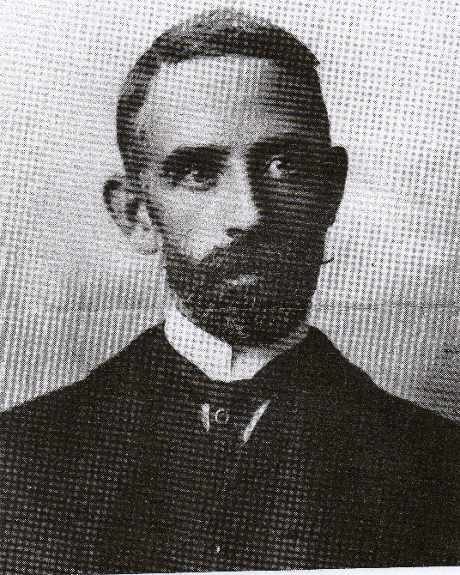
Writing on William Cobbett in your March edition, Charles Stuart, Chairman of the William Cobbett Society, makes passing reference to another of Farnham’s famous sons, George Sturt. Generally less well known than Cobbett, Sturt was an inquisitive and methodical observer of the social changes happening between the end of the nineteenth century through to the time of his death in 1927, whose writing attracted the attention of three eminent literary critics - F.R Leavis, Raymond Williams and Richard Hoggart, himself a one time resident of Farnham. Sturt’s roots were always firmly in Farnham where he grew up, attending the Grammar School and, briefly, the School of Art
Born in 1863, he spent his early childhood with his parents, brother and two sisters living above the stationery shop and newsagents at 18 The Borough, which his mother, Ellen, managed with the help of her spinster sister, Ann, while Sturt’s father, Francis, ran the family wheelwright’s shop across Bear lane from 84 East Street where his own parents George and Sarah lived with two of their children, John and Sarah. In A Small Boy in the Sixties (1927) Sturt recounts his schooling at Miss May’s Infant School at 93 East Street and at Mr Poppleton’s small secondary school before moving to the Grammar School. There are also accounts of local townsfolk, the annual mayhem on ‘Squib Night’, the growing and harvesting cycle in Farnham’s hop fields and his mother’s work at the shop. It is this ability to construct a detailed portrait of a local community with its customs and characters at the end of the Victorian era and, in this case, the place of a particular family within it, that has such wide appeal and is so characteristic of all of Sturt’s books.
The same keen observation and clarity of description is evident in The Wheelwright’s Shop (1923) which The New Statesman correctly predicted could well become a classic and the Times Literary Supplement remarked “shows the author’s combination of the gifts of the handicraftsman with the powers of a writer in a way not common in English Literature.”
Having taught at the Grammar School from 1878 until 1884, Sturt, with his brother Frank, took over the management of the wheelwright’s shop on their father’s death. Initially he enjoyed learning and (where permitted) practising the old skills. Beginning so late in life he recognises his limitations but is willing “to act as boy to any of the men who might want a boy’s help”. His respect for the craftsmen who passed down traditional skills from one generation to the next is very evident.
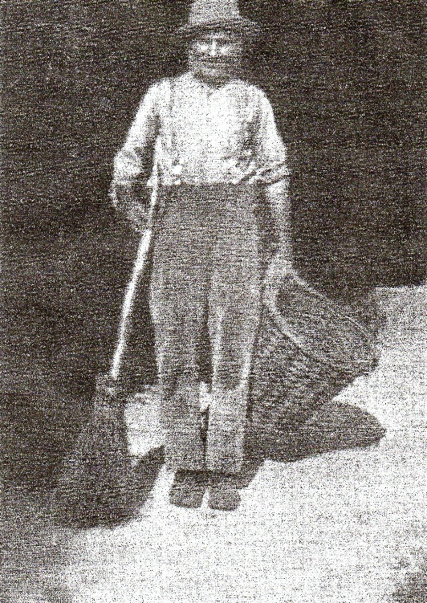
As early as January 1891, Sturt was considering selling the business in which his brother Frank had little interest or involvement. “The misery of being a socialist employer of labour” may have been partly meant in humour but managing the workshop when demand for the wheelwrights’ particular skills was beginning to decline with the advent of the car and new technology contributed to Sturt’s desire to leave the business. However, he was able to appoint a foreman manager – William Goatcher – to run the enterprise, allowing him to join his two unmarried sisters, Mary and Susan, at Vine Cottage in the Bourne and concentrate on writing. It was here that Sturt came across Fred Grover (Bettesworth) and his epileptic wife Lucy whose traditional way of life as ‘cottagers’ Sturt described with understanding and humour in the ‘Bettesworth’ books. Fred (pictured left) worked on and off as a gardener for Sturt at Vine Cottage where he entertained his employer with his “pleasant garrulity” and “queer anecdotes and shrewd observations” of a way of life which was all but lost by the end of the nineteenth century. It was from these conversations, covering the period from December 1892 until Fred’s death in 1905, that Memoirs of a Surrey Labourer (1907) was born, though Sturt never informed Fred of the book, as this knowledge “would send him boastfully drinking about the parish and make him intolerable to his familiars and useless to any employer”. The account of Fred’s tenderness and dignity in laying out Lucy on her death bed is deeply moving.
Published in 1912, Change in the Village, is a more sombre and probably Sturt’s most significant work. In it, he contemplates in greater detail the passing of a traditional way of life with its focus on seasonal activities and such traditional skills as William Cobbett described in Cottage Economy, and its emphasis on thrift and self-sufficiency. The upheaval in rural social structures and customs, brought about by factors such as new agricultural practices and technological advances, and aggravated by the loss of ‘cottagers’ access to grazing on the common land through enclosure laws is profound. Locally, the coming of the railway (1849) and the Aldershot Garrison (1855) and, most especially, a mains water supply accelerated the pace of change more quickly in The Bourne valley, perhaps, than in other similar communities. The area was rapidly being discovered as a ‘residential centre’. Instead of being one of a group of villagers, “tolerably independent of the rest of the world”, the men and women of the valley are increasingly dependent on competing for and acquiring regular, stable employment, much of it provided by the newly arrived, leisured middle class. Traditional, occasional employment as carters, in the hop gardens or harvest work are giving way to building work and labouring on the roads and railways, with young girls seeking ‘a little place for a start in domestic service’ and many young boys getting jobs in the town, often as errand boys.
It must have been hard for Sturt to react to the changing situation without some degree of ambivalence. Although real destitution was rare, life for ‘the cottagers’ was hard and Sturt is quick to point out that there was nothing of the popular rural idyll about life in the valley where the rural, peasant tradition had deep roots. He describes a local man, well known to him, as “adapting himself so far as suited him to a more commercial economy” but not being out of place had he been transferred back to the eighteenth century.
Today, we have the advantage of knowing how these changes played out. For Sturt consequences of ‘eviction’ from the age-old way of life were unknown but inevitable. “We have.... a shattered community; a living engine whose flywheel of tradition is in fragments and will not revolve again” The move towards a wage- earning environment brought a new leisure but the villagers could find few ways to use the spare hours after a long day of monotonous and mentally undemanding labour. Speaking of a coal-haulier known to him, Sturt suggests wryly that his “experience of life cannot have done great things for him”.
There are signs, however, of a growing engagement with the church, the press and politics. This “process of self-unfolding” convinces Sturt that greater changes were yet to come with the poor, “helped a little, or hindered a little by outsiders”, steadily moving along a course of their own making.
An initial stroke in 1916 followed by a second in 1920 left Sturt much incapacitated. He suffered a further blow with his sister Mary ‘s death in 1922.
In his essay on Sturt in Literary Englands (1993) David Gervais asks “Has any English writer known his own particular England as closely as Sturt knew his”
For an analysis of the influence of George Sturt on the poet Edward Thomas click here.
Richard Sandars

